# Question:

Do descriptive characteristics of Oscar awarded actors and directors such as their sexual orientation, religion, or ethnicity, correlate with the ratings or number of ratings their movie receives?

# Methodology:

This study uses data collected from nndb.com that was placed in Kaggle. This data includes a list of ~440 actors and directors who received Oscar awards, generally for best actor or best director. This data includes a series of personal information on each individual including their sexual orientation, ethnicity, and religion. This data also includes the movie title they received their Oscar for. Using this movie title, we web scraped metacritic.com to get an average rating and number of reviews from critic or professional reviews, and web scraped imdb.com to get the rating and number of reviews from normal individuals reviews. Using this information, we ran an ordinary least squares regression to see if any individual characteristics correlated with the outcomes of interest.

# Data:

We excluded observations that were not found in Metacritic, leaving us with 260 observations. Below are the summary statistics of those observations:

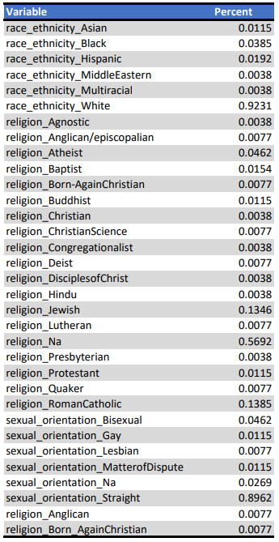

There are five outcome variables of interest; number of public votes (or ratings), number of professional votes, professional average rating, public average rating, and public minus the critic (or professional) rating. We including a year variable that was normalized so that 0 represents the oldest year an Oscar was awarded (1930) in this dataset. All other variables are 0 or 1 for an individual characteristic. The group excluded from the regression was white, straight, Christians. Consequently, if any variables are significant in our results, it will be as compared to white straight Christians.

# Results:

List of measured characteristics, and if each one had a significant impact on an outcome of interest:

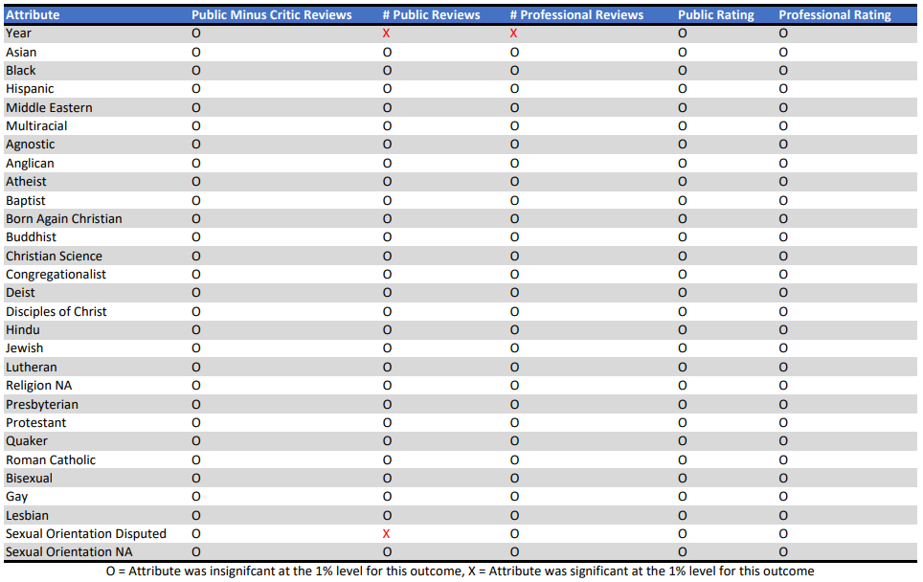

Each of these results are only considered significant if they are significant at the 1% level. If a result had more than a 1% chance of not being statistically significant, the result was considered zero or null.

**Outcome: Number of professional ratings**

Besides year, which was positively correlated with the number of professional votes, no individual characteristics were significantly correlated with this outcome.

**Outcome: Number of public ratings**

Besides year, which was positively correlated with the number of professional votes, the only individual characteristic that was significant was individuals whose sexual orientation was a matter of dispute who on average received 667,600 more public ratings than straight individuals.

**Outcome: Professional Rating / Review Score**

None of the tested characteristics were significantly correlated with the ratings that professionals gave the movies.

**Outcome: Public Ratings / Review Score**

None of the tested characteristics were significantly correlated with the ratings that normal individuals gave the movies.

**Outcome: Public Score Minus the Critic Score**

None of the tested characteristics were significantly correlated with the difference between the public average score and the critics average score for the movie.

As the vast amount of unfilled space in the above table demonstrates, there were almost no significant correlations between identity characteristics and the outcomes of interest.

# Analysis and Conclusion:

These results suggest that there is no correlation between the ethnicity, sexual orientation, or religion of Oscar award winners and the number or score of ratings they receive from both critics and the public. There were only three awards given to individuals whose sexual orientation was a matter of dispute. The small sample size suggests that we should not consider the difference in public reviews individuals with disputed sexual orientation received to be significant until we test a larger sample size.

Despite the previously discussed exception these results suggest that characteristics of actors and directors such as sexuality, race, and religion do not correlate with the number of reviews or the ratings the movies receive. This study uses only movies who were nominated for Emmys in its analysis which could bias the results. This analysis also relies on the accuracy of this single dataset. These weaknesses should be accounted for when understanding our findings.

In the future, a similar study could be done using a larger sample size that included directors and actors that were not nominated for any public awards. With that analysis we would have a fuller understanding of how these characteristics impact reviews and ratings.

Original Dataset:

[Demographics of Academy Awards (Oscars) Winners | Kaggle](https://www.kaggle.com/fmejia21/demographics-of-academy-awards-oscars-winners)